**PRACTICAL 1**

**AIM: Implement following HTML 4 Tags along with necessary attributes: HTML 4 Structure Tags, Heading Tags, Paragraphs, Text Formating Tags, Link and List Tags, Image, Fom, Table, Iframe, Div.**

**SOLUTION:**

<TITLE> TAG🡪 used to write name of the document which is later showed in the tabs name.

<CENTER> TAG🡪 it is used to make content in center.

<HEAD> TAG🡪 it is used to make headings or may be used in search engine optimization.

<BODY> TAG🡪 it is used to define main content inside it.

<H1> TAG🡪 used to specify the size of the heading.

<HR> TAG🡪 used to display a horizontal line in the body section.

<P> TAG🡪 it is used to make a section inside which is text is inscribed in it.

<TABLE> TAG🡪used to make a table inside body

<TD> TAG🡪 it is used to insert column entries in the table.

<TR> TAG🡪 it is used to insert row entries in the table.

<TH> TAG🡪 it is used to insert heading of the table.

<IFRAME> TAG🡪 it is used to insert a frame inside the body and then it takes link to be inscribed.

<FORM> TAG🡪 it used to make a form and also use its subtags

<INPUT> TAG🡪 it is used to input the entries like that of attributes.

<IMG> TAG🡪 it is used to display images in the body and takes the path of image as compulsory.

**First file**

**OUTPUT:**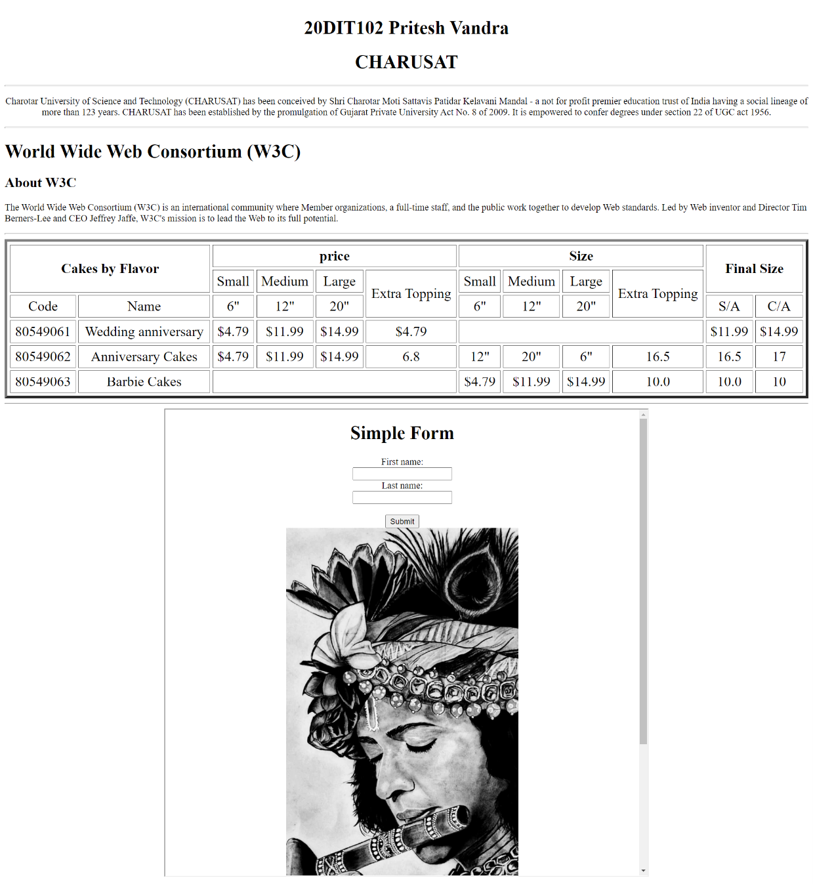

**CONCLUSION:**

Here have made a simple page using html and css tables and also used iframe.